# Spring MVC 4 TUTORIAL

**Require**

* Maven
* Tomcat Server

Step 1: Open eclipse IDE, create web project

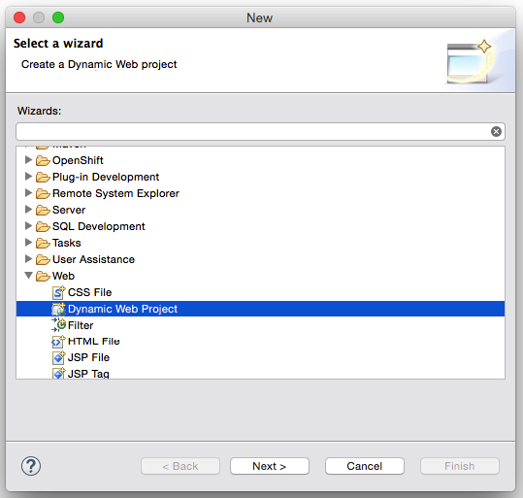

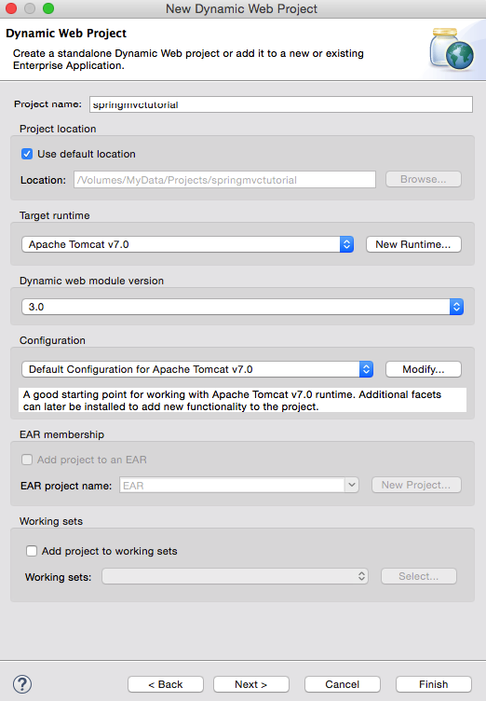

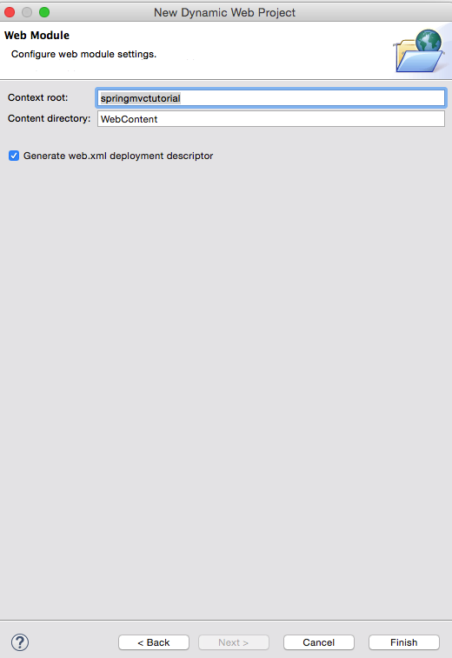

Step 2: Convert project to maven

* Right click on project -> Configure -> Convert to Maven project 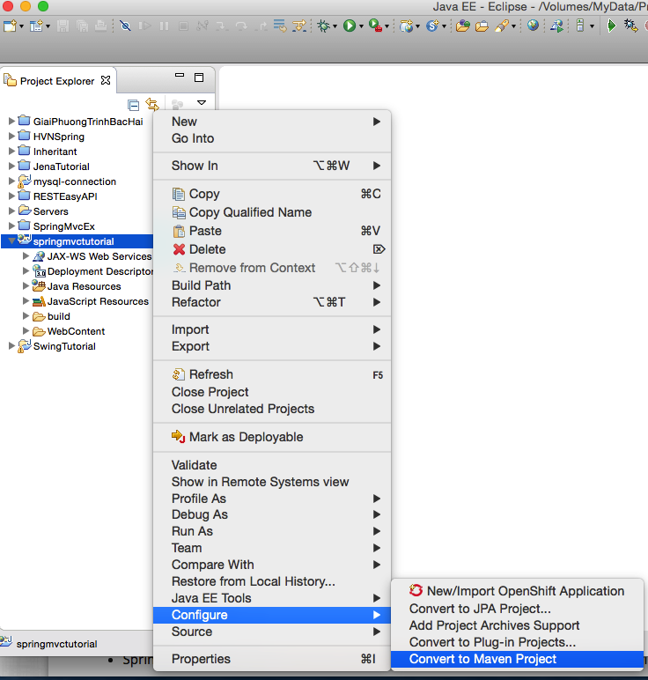

Step 3: Add dependencies to POM file

<dependencies>

<dependency>

<groupId>org.springframework</groupId>

<artifactId>spring-context</artifactId>

<version>4.1.1.RELEASE</version>

</dependency>

<dependency>

<groupId>org.springframework</groupId>

<artifactId>spring-aop</artifactId>

<version>4.1.1.RELEASE</version>

</dependency>

<dependency>

<groupId>org.springframework</groupId>

<artifactId>spring-webmvc</artifactId>

<version>4.1.1.RELEASE</version>

</dependency>

<dependency>

<groupId>org.springframework</groupId>

<artifactId>spring-web</artifactId>

<version>4.1.1.RELEASE</version>

</dependency>

<dependency>

<groupId>javax.servlet</groupId>

<artifactId>jstl</artifactId>

<version>1.2</version>

</dependency>

<dependency>

<groupId>commons-logging</groupId>

<artifactId>commons-logging</artifactId>

<version>1.1.3</version>

</dependency>

</dependencies>

Step 4: Create springmvctutorial-servlet.xml file under WebContent/WEB-INF

<?xml version=*"1.0"* encoding=*"UTF-8"*?>

<beans xmlns=*"http://www.springframework.org/schema/beans"*

xmlns:mvc=*"*[*ttp://www.springframework.org/schema/mvc"*](ttp://www.springframework.org/schema/mvc%22)

xmlns:context=*"http://www.springframework.org/schema/context"*

xmlns:xsi=*"http://www.w3.org/2001/XMLSchema-instance"*

xsi:schemaLocation=*"*

*http://www.springframework.org/schema/beans*

*http://www.springframework.org/schema/beans/spring-beans.xsd*

*http://www.springframework.org/schema/mvc*

*http://www.springframework.org/schema/mvc/spring-mvc.xsd*

*http://www.springframework.org/schema/context*

*http://www.springframework.org/schema/context/spring-context.xsd"*>

<context:component-scan base-package=*"com.springmvctutorial.controller"*/>

<bean id=*"viewResolver"*

class=*"org.springframework.web.servlet.view.UrlBasedViewResolver"*>

<property name=*"viewClass"*

value=*"org.springframework.web.servlet.view.JstlView"* />

<property name=*"prefix"* value=*"/WEB-INF/jsp/"* />

<property name=*"suffix"* value=*".jsp"* />

</bean>

</beans>

Step 5: Replace the following content in web.xml file.

<?xml version=*"1.0"* encoding=*"UTF-8"*?>

<web-app xmlns:xsi=*"http://www.w3.org/2001/XMLSchema-instance"* xmlns=*"http://java.sun.com/xml/ns/javaee"* xsi:schemaLocation=*"http://java.sun.com/xml/ns/javaee http://java.sun.com/xml/ns/javaee/web-app_3_0.xsd"* id=*"WebApp_ID"* version=*"3.0"*>

<display-name>springmvctutorial</display-name>

<welcome-file-list>

<welcome-file>index.jsp</welcome-file>

</welcome-file-list>

<servlet>

<servlet-name>springmvctutorial</servlet-name>

<servlet-class>

org.springframework.web.servlet.DispatcherServlet

</servlet-class>

<load-on-startup>1</load-on-startup>

</servlet>

<servlet-mapping>

<servlet-name>springmvctutorial</servlet-name>

<url-pattern>/</url-pattern>

</servlet-mapping>

</web-app>

Step 6: Create a index.jsp file in WebContent

<%@ page language=*"java"* contentType=*"text/html; charset=UTF-8"*

pageEncoding=*"UTF-8"*%>

<!DOCTYPE html PUBLIC "-//W3C//DTD HTML 4.01 Transitional//EN" "http://www.w3.org/TR/html4/loose.dtd">

<html>

<head>

<title>Spring MVC Tutorial</title>

<style type=*"text/css"*>

**body** {

background-color: *#EEEEEE*;

}

</style>

</head>

<body>

<br>

<div style="text-align: *center*">

<h2>Hey guy. This is index page</h2>

<a href=*"welcome"*>Click here to see welcome page</a>

</div>

</body>

</html>

Step 7: Create welcome.jsp file in WebContent/WEB-INF/jsp folder

<%@ page language=*"java"* contentType=*"text/html; charset=UTF-8"*

pageEncoding=*"UTF-8"*%>

<!DOCTYPE html PUBLIC "-//W3C//DTD HTML 4.01 Transitional//EN" "http://www.w3.org/TR/html4/loose.dtd">

<html>

<head>

<title>Spring MVC Tutorial</title>

<style type=*"text/css"*>

**body** {

background-color: *#eeeeee*;

}

</style>

</head>

<body>

${message}

</body>

</html>

Step 8: Create a package com.springmvctutorial.controller and add new java file as bellow.

package com.springmvctutorial.controller;

import org.springframework.stereotype.Controller;

import org.springframework.web.bind.annotation.RequestMapping;

import org.springframework.web.servlet.ModelAndView;

@Controller

@RequestMapping("/")

public class HelloWorld {

@RequestMapping("welcome")

public ModelAndView helloWorld() {

String message = "Hello this is welcome page";

return new ModelAndView("welcome", "message", message);

}

}

---end---